**EXERCISE-15**

**1.** APP with header and footer and show joke button

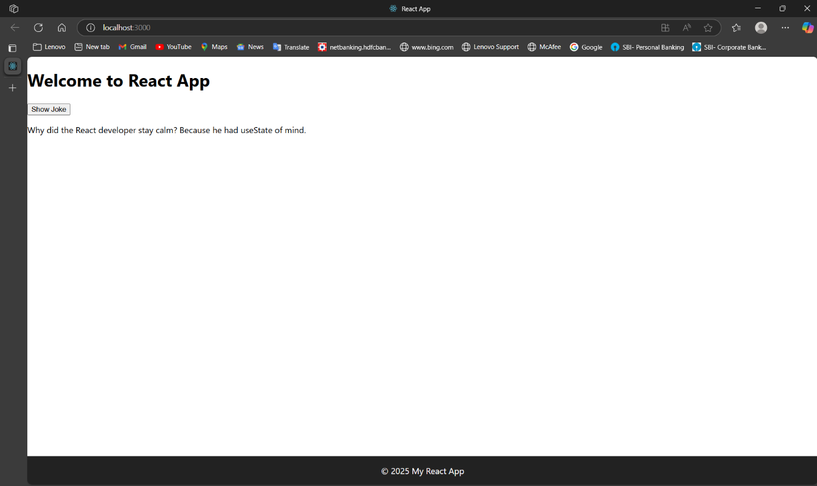

**2.** Inline CSS

**3.** Internal CSS

**4.** External CSS

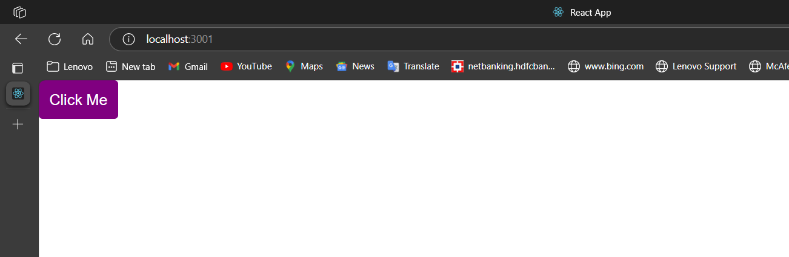

**5.**count operation and increment button

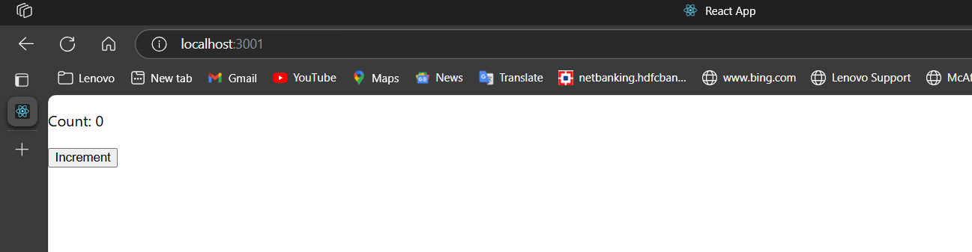

By clicking on increment button

**6,7.**

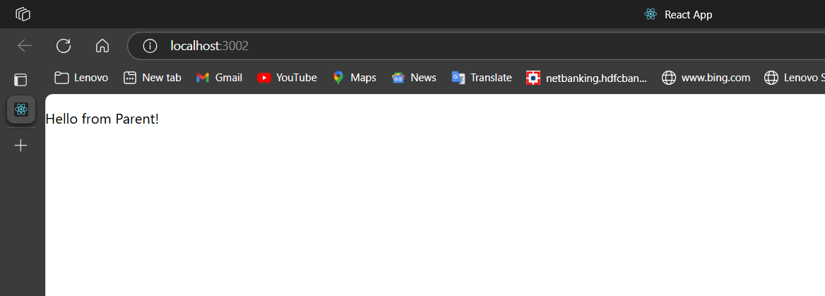

**8.** State Hooks

By clicking on increase the count will increase

By clicking on decrease the count will decrease

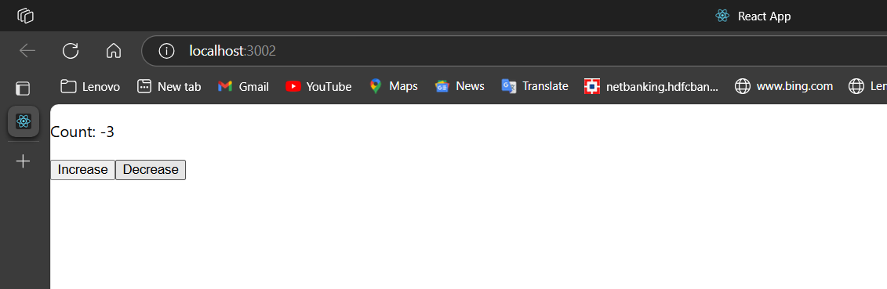

**9.**random joke by clicking on new joke

**10.** **Ref Hooks**

We have to type something and we have click on focus input it will focus

**11**. **Context Hooks**

By default light theme

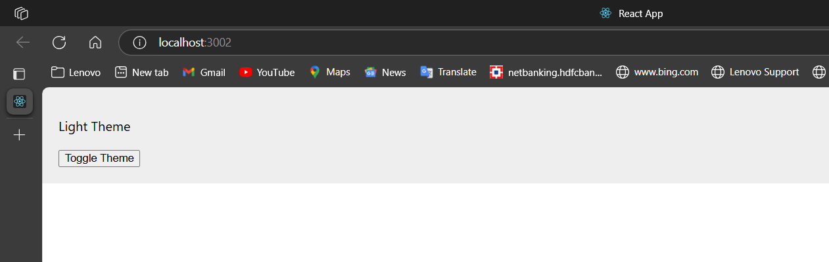

By clicking on Toggle theme it will change to dark theme

**12.**  **Passing Values from a Form**

**i)we have to type input name and email**

**ii)**we have to type input name and email and we have click on the submit button

